**Design Calculation**

The design options for the proposed power plant operate with a reheat regenerative rankine cycle. The diagram of each design is shown below.

**Design Option 1**

The schematic and T-S diagram of design option 1 are shown as follows:

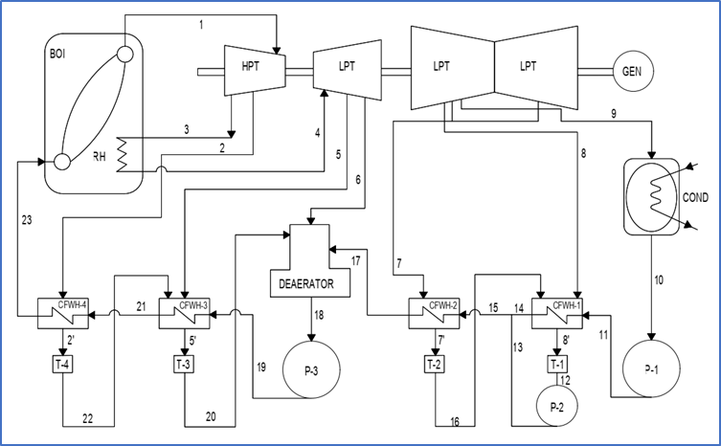

**Figure _.** Schematic Diagram of Design Option 1

Design option 1 consists of 5 regenerative processes with 1 open feed water heater and 4 closed feed water heater. The design option has a thermal efficiency of 33.68 %.

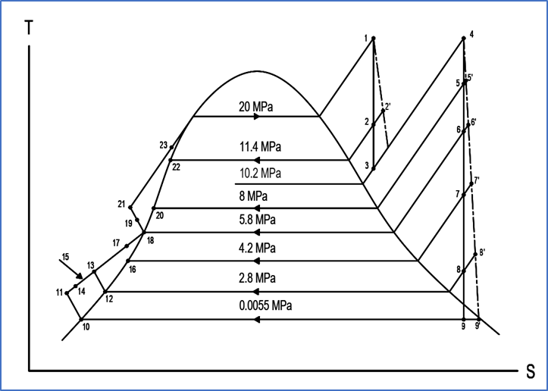

**Figure _.** T-S Diagram of Design Option 1

The figure above shows the thermodynamic relationship within the design. The cycle consists of 23 state points with 8 operating pressures.

**Design Option 2**

The schematic and T-S diagram of design option 2 are shown as follows:

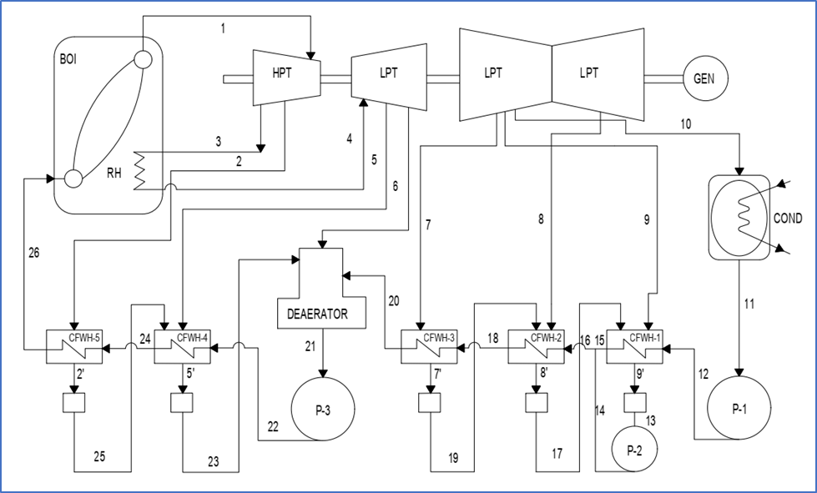

**Figure _.** Schematic Diagram of Design Option 2

Design option 2 consists of 6 regenerative processes with 1 open feed water heater and 5 closed feed water heater. The design option has a thermal efficiency of 34.21 %.

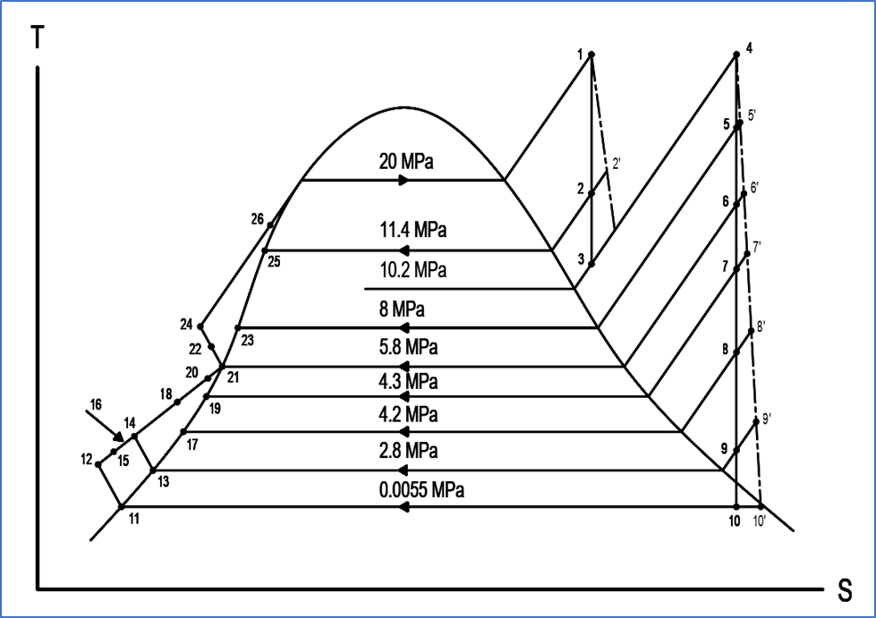

**Figure _.** T-S Diagram of Design Option 2

The figure above shows the thermodynamic relationship within the design. The cycle consists of 26 state points with 9 operating pressures.

**Design Option 3**

The schematic and T-S diagram of design option 3 are shown as follows:

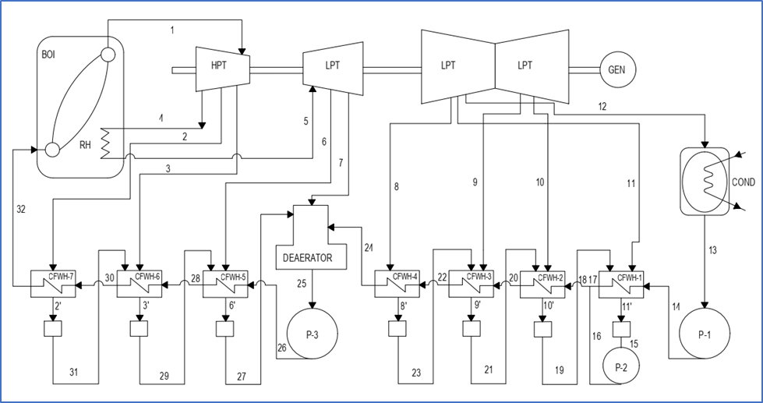

**Figure _.** Schematic Diagram of Design Option 3

Design option 3 consists of 8 regenerative processes with 1 open feed water heater and 7 closed feed water heater. The design option has a thermal efficiency of 35.08 %.

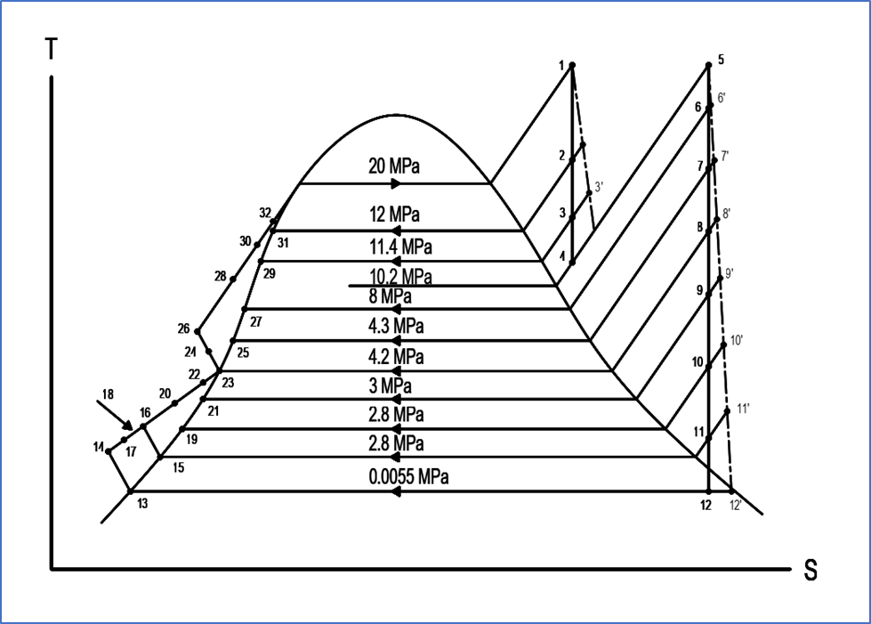

**Figure _.** T-S Diagram of Design Option 3

The figure above shows the thermodynamic relationship within the design. The cycle consists of 32 state points with 11 operating pressures.